Final Report Henrik Pröpper
Dates of Internship from: 01/03/2022 to present
Academic year 2021 / 2022
Name of University Cambridge University
City/town, country Cambridge, UK
Supervisor Prof. dr. Lee de-Wit
Leiden study program Adv. MSc in International Relations and Diplomacy
Faculty Global Governance and Global Affairs

Aims, relevance and results of the project

The organization

The aim of the Political Psychology Lab at Cambridge is to apply psychological insights to (1) investigate political decision-making in the real world, and (2) understand the cognitive mechanisms of voting, thereby contributing to the improvement of democratic progress. Accordingly, the lab attempts to tackle the “challenges of today” through the examination of human psychology, including personality traits (e.g., right wing authoritarianism), heuristics (e.g., “correctness of voting”), structural constraints (e.g., voting systems) and finally, political- and cultural schemata.

The project’s vision

My project at Cambridge focuses on the latter. Guiding by the central question “how can we encourage billions of people to embrace compromise, to be tolerant, and to prioritize the “we” over the “me”?”, I explored if the promotion of a hopeful view of humankind could be channeled towards more pro-social behavior in complex social dilemmas such as climate change, dehumanization, and political polarization.
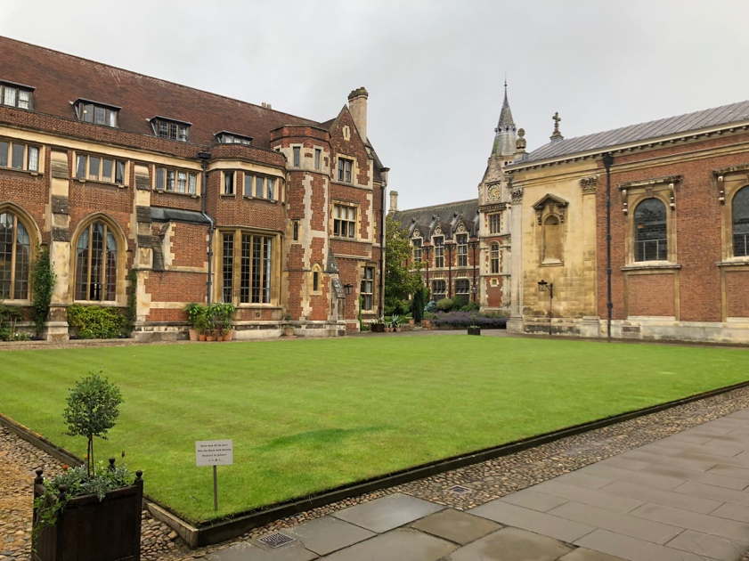
Over the last few months, I have often used international climate change mitigation to explain the project. Suppose that you would have to explain what is necessary for international cooperation to occur. Some might argue that we need a technological solution, others would direct their attention to authority figures, popular support, or even global sanctions. However, we often forget the importance of the “cognitive” step which must be established before international cooperation can actually happen. Indeed, one must first believe that sustainable global cooperation is possible.

Project activities

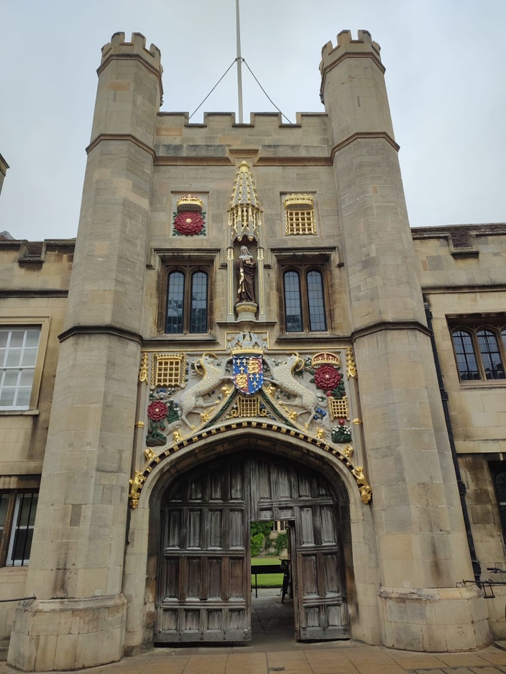
Based on this vision above, one could expect that the primary activity of this project would have been to devise an intervention to target people’s assumptions about human nature and then to measure to what extent this leads to more pro-social behavior. The reader would be right in the expectation that a careful study of possible interventions is of vital importance, and as of today, this question is one of the central themes of my proposed PhD thesis at Science Po and Cambridge.

However, we are not just looking at a solution to a problem. We do not yet know what the actual problem is. To put it differently, before one can devise an intervention that can target the cognitive mechanisms that links people’s perception of human nature to cynicism (or hope) in international politics, one must first understand what people actually believe.

Three stages of research

Yet, to understand people’s beliefs about human nature, one must first know what to ask. The first step was therefore to perform an inclusive and holistic literature review – scientific fields ranged from evolutionary biology, anthropology, genetics, to economics, psychology, crisis-research, sociology, international relations, and philosophy.

Following the review of present literature, I performed interviews with international experts at e.g., Oxford, Science Po, Duke and UCL. Three paraphrases capture the direction and thoughts of these interviews:
- Humans are neither hawkish nor dovish: yet confusion about the nature of individual- and group level selection can generate false inferences about our other regarding tendencies.
- Growing up, I was taught that I would not be helped on the streets when in danger: they said it is better to call “FIRE” than to call for help, especially as a woman. Yet, despite this negative view, it is amazing how many people help during emergencies.
- When we say human nature, we mean dark. When we say a “realistic” view of human nature, we often think that this means that we must accept that humans are competitive and violent.

In parallel with these conversations and the literature review, I developed behavioral vignettes for semi-structured qualitative interviews with volunteers. Three paraphrased responses give some insights into the thoughts of the volunteers:
- Following the behavioral vignette on international cooperation:
- Most people tend to be pro-social rather than sneaky. People will naturally try to cooperate with each other; however, this is if and only if we minimize the influence of companies that want to make a profit.
- Following the behavioral vignette on prison-systems that give people second chances:
- My first reaction to this prison “Halden” is: where is the justice? Where is the retribution? Yet, my second thought is different. We have a saying in China: sometimes you have to kill the chicken to scare of the monkeys. However, did the chicken truly do anything that is worth killing? Do we choose to give up on the individual or do we try to change the way we see others?
- Following the behavioral vignette on honesty:
- If you do not study human psychology, if you do not think about human nature a lot, then, the predominant idea is that all people are selfish, and that most people will act in that way.

Contribution of the project to IR and future plans

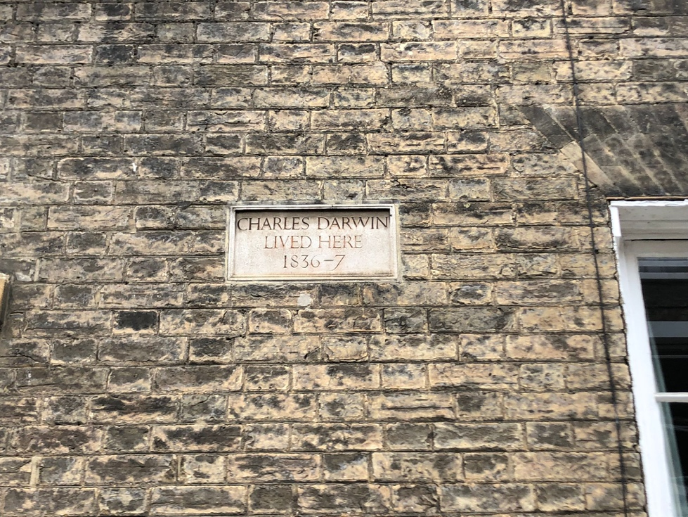
Over the last few months, I have seen and learned that, although most people may not be fundamentally selfish actors, their beliefs do reveal them to be self-interest theorists (Miller & Ratner, 1988). People and indeed IR practitioners and politicians tend to perceive human nature as primarily tribal, competitive, and selfish. Additionally, we seem to think that this view is “Realistic”, normative, and only natural, thereby creating the circumstances which allow for the expression of precisely those traits assumed to be in our nature.

This is a choice, and it is a choice we do not have to make. Over the last decade, a progressive movement has risen with the goal to expand our definition of who we are and what we can be, and my aim is contribute to this movement. During my second year of the Masters, in my PhD, and later in my professional life, I will strive to stimulate a more hopeful view of human nature – and thereby, as a cognitive gateway, nurture a society in which cooperation, empathy and tolerance are seen as truly “realistic”.

Bibliography

Gat, A. (2000). The causes and origins of "primitive warfare": Reply to Ferguson. Anthropological quarterly, 73(3), 165-168.
Miller, D. T., & Ratner, R. K. (1998). The disparity between the actual and assumed power of self-interest. Journal of personality and social psychology, 74(1), 53.
Rathbun, B. C. (2009). It takes all types: social psychology, trust, and the international relations paradigm in our minds. International Theory, 1(3), 345-380. Wendt, A. (1999). Social Theory of International Politics. New York: Cambridge University Press.

