Final Report Minerva Scholarship

Dates of stay abroad from: 03/09/2019 up to (and incl.): 31/01/2020
Academic year 2019 / 2020
Name of University abroad Yale University
City/town New Haven, CT
Country USA
Leiden study program Psychology (research) MSc (Developmental track)
Leiden study year 2018 – 2020
Bachelor / Master Master
Faculty Social and Behavioral Sciences

Aim, relevance, and results of the project
During my research internship at Yale Child Study Center (YCSC), I investigated the neural responses of adolescent girls and boys between ages of 12-17 to acceptance and rejection feedback they receive from unknown peers. I specifically looked at how adolescents’ EEG responses changed as a function of their reported levels of social anxiety and stages of pubertal development. My study specialization includes studying different developmental periods such as adolescence and both typical and typical changes that occur in brain and behavior over the course of life. With this research project at YCSC, we aimed to better understand neural mechanisms underlying the development of social anxiety especially in adolescence when fundamental changes in social environment and brain maturation take place. I carried out two projects focusing on similar topics and worked on two manuscripts. The preliminary results of the projects have shown that older adolescents who are in the later stages in puberty showed different responses when faced with peer feedback compared to younger adolescents in earlier stages of puberty. Additionally, neural responses to peer feedback was different depending on social anxiety levels. These results demonstrate that adolescents in different developmental stages who experience different levels of social anxiety can be more or less sensitive to social evaluation as reflected by the EEG measures.
Results of these projects I worked on throughout my research internship inspired me to further work on projects that are related to the processing of social information in the brain and how differences in individuals’ experiences of anxiety would influence this. I am hoping to now work on a related project for my thesis.

Contribution of project to science
Results of the research project I carried out as a part of my internship has shown how pubertal development and social anxiety relate to adolescents’ social and affective processing. Especially, it provides support for the idea that adolescence is a sensitive period for social-emotional information as substantial neurobiological, behavioral, and social changes take place. Thus, it is important for future research to identify the typical and atypical developmental trajectories for the neural mechanisms underlying social and emotional information processing, and how they relate to emergence and maintenance of psychological problems.

Future plans for PhD
Upon completion of my studies, I am hoping to pursue a PhD in psychology which will be the next step to become an academic in this field. A couple years from now, I would like to see myself as a PhD candidate at a reputable research institute working on projects that are related to social information processing, learning from social interactions with others and how this would lead to emergence and maintenance of psychological problems starting from young ages. I believe both the courses I have taken and research projects that I received supervision for at Leiden University, as well as the research experience at YCSC have prepared me for this next stage. This research internship has provided me with invaluable experience, skills, and knowledge that will help me successfully complete my research master studies; and it has shown me that the career path that I have chosen is indeed the one that I would be excited to follow.

Appendix A
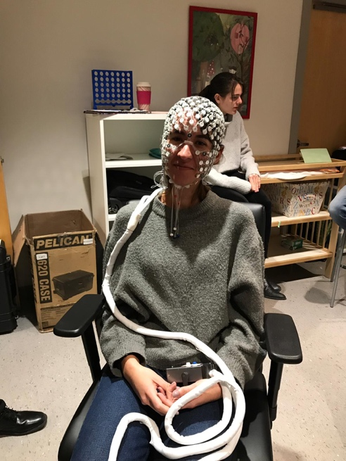
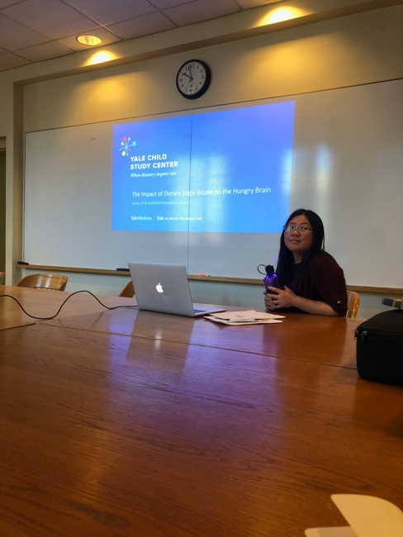
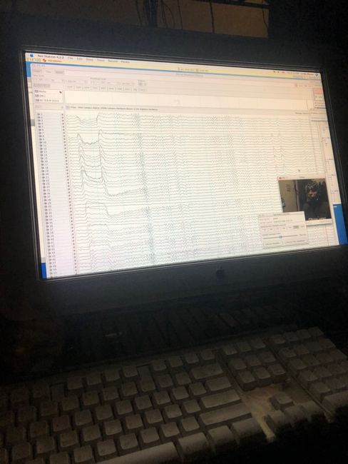
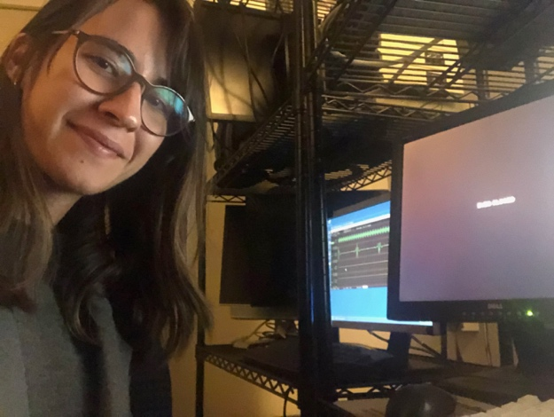
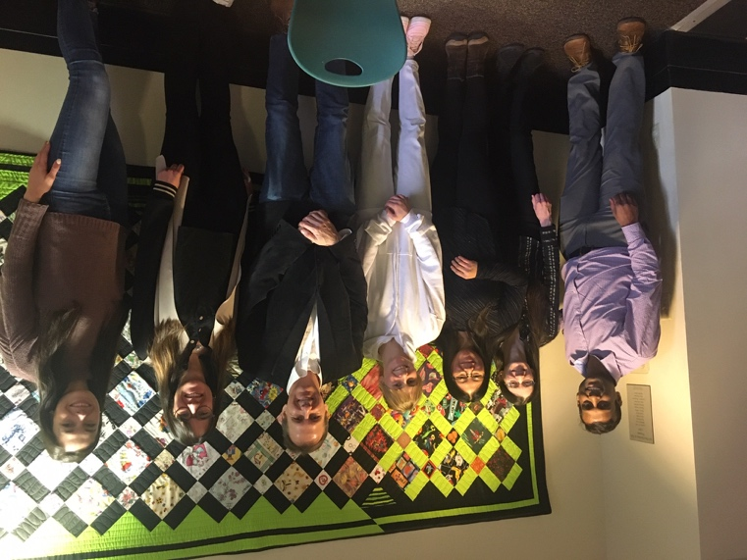
Photos showing some of the tasks I performed, and the lab environment and members
Figure 1. Me volunteering for MR-compatible EEG-training
Figure 2. Dr. Jia Wu, a researcher in our lab at Yale, is presenting her research that I also worked on together with her
Figure 3. From an EEG testing session in the lab that I carried out
Figure 4. Me testing in the lab.
Figure 5. Our lab photo with lab members including our PI, Dr. Crowley (third from right), Dr. Wu (third from left), Dr. Morie (second from left), and me (second from right).

